CSA0603-DESIGN AND ANALYSIS OF ALGORITHM(CHAPTER 1- PRACTICALS)

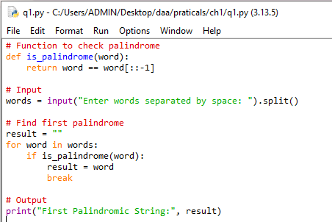
Exp1: First Palindromic String in an Array

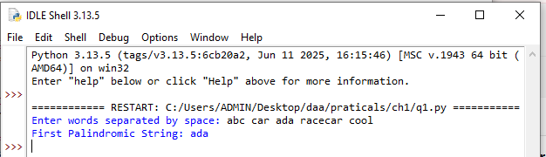
Exp 2 : Count Elements Common Between Two Arrays

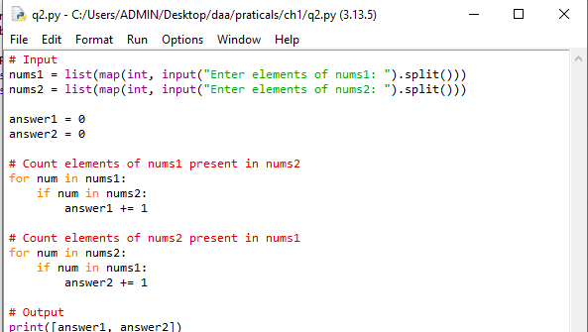

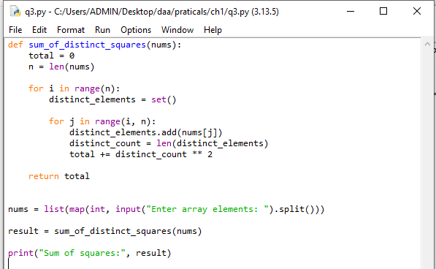
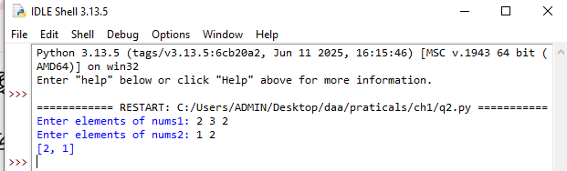
Exp 3: Sum of Squares of Distinct Counts of All Subarrays

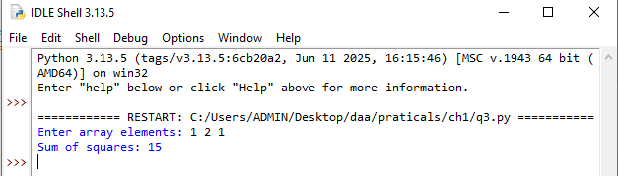
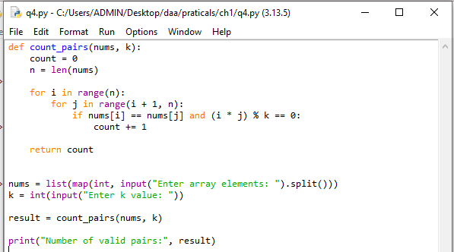
Exp 4: Count Equal Pairs with Index Product Divisible by K
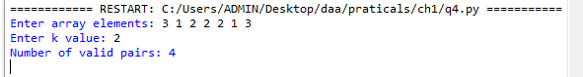

Exp 5: Find the Maximum Element in an Array
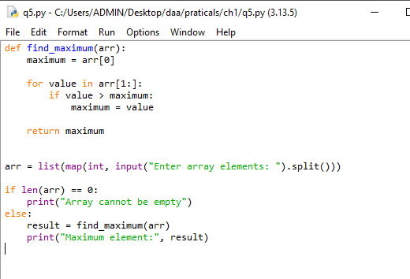

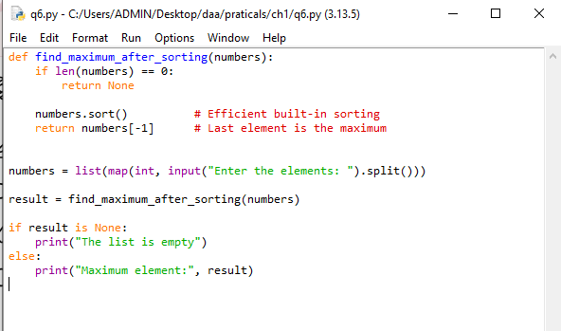
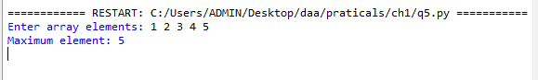
Exp 6: Sort the List and Find the Maximum Element
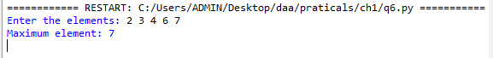

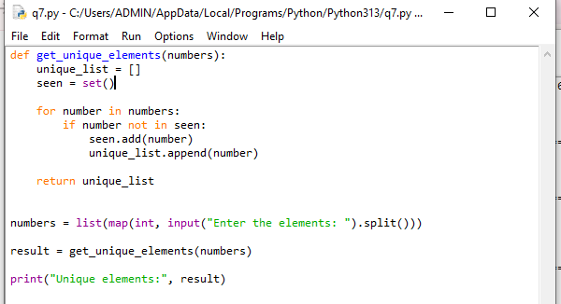
Exp 7: Find Unique Elements in a List
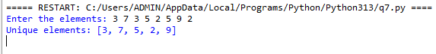
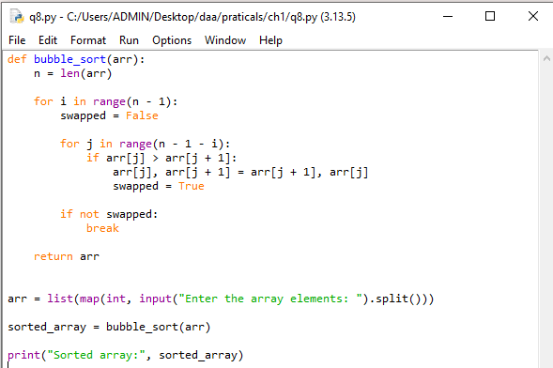
Exp 8: Sort an Array Using Bubble Sort
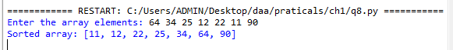

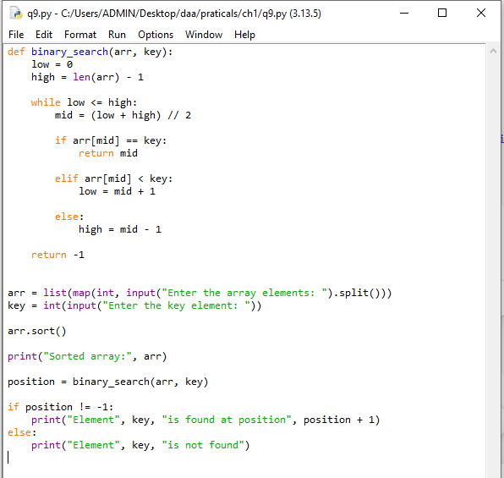
Exp 9: Search an Element Using Binary Search

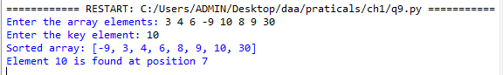
Exp 10: Sort an Array in O(n log n) Time Using Heap Sort
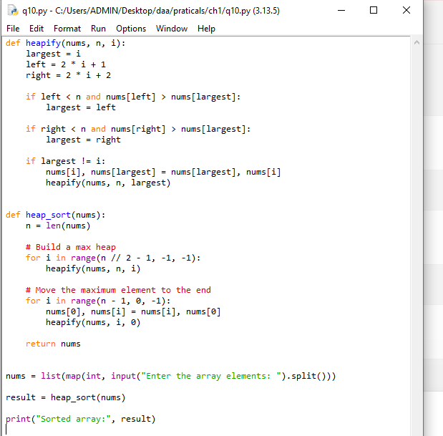

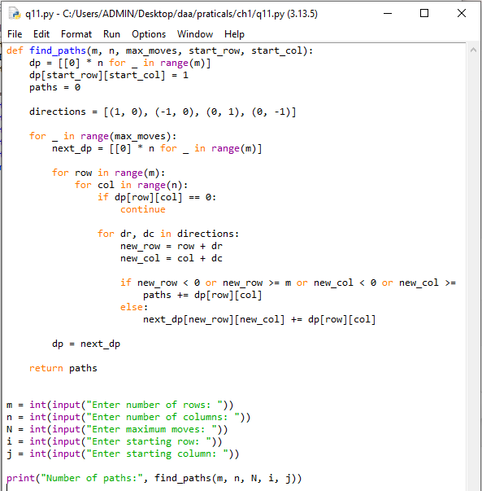
Exp 11: Count Paths to Move a Ball Out of a Grid

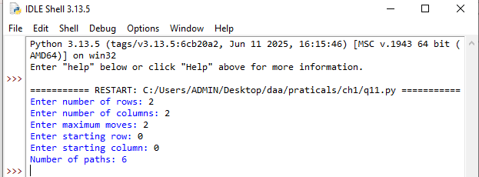

Exp 12: House Robber in a Circular Arrangement

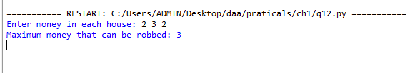

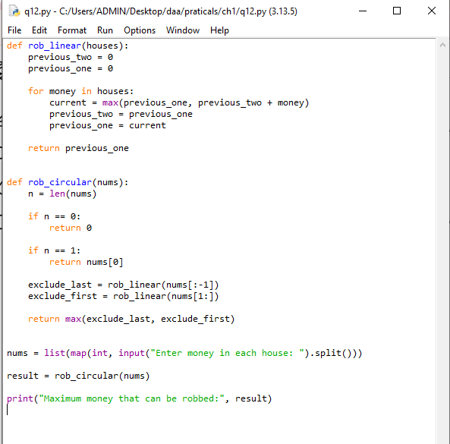
Exp 13: Count Distinct Ways to Climb Stairs
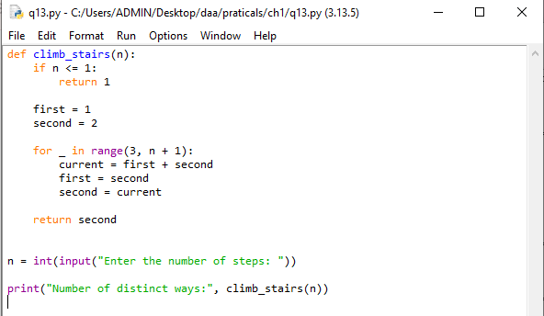

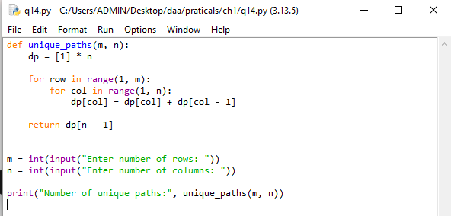
Exp 14: Count Unique Paths in a Grid
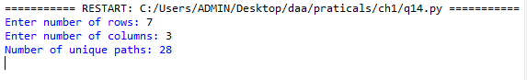

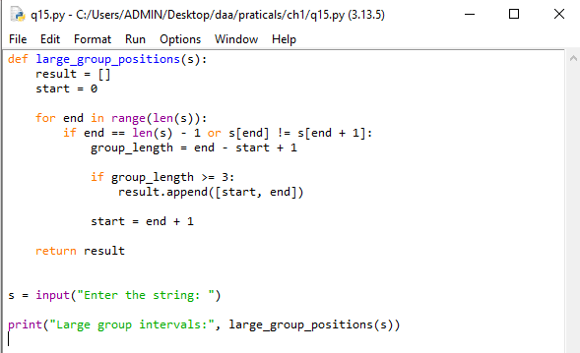
Exp 15: Find Large Groups in a String

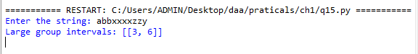
Exp 16: Conway’s Game of Life
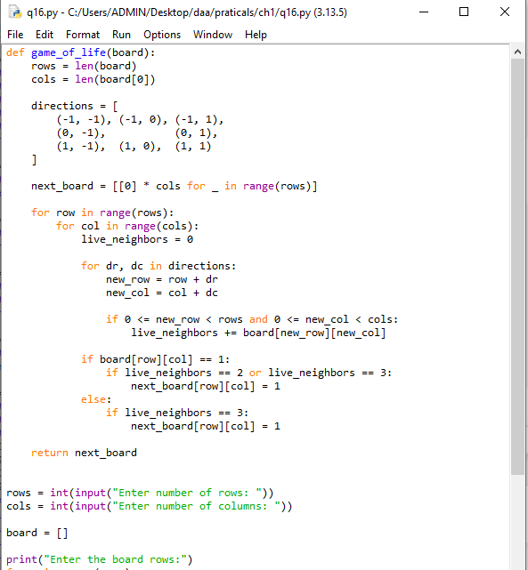
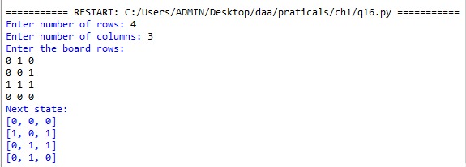

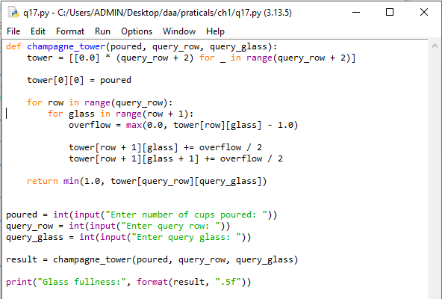
Exp 17: Champagne Tower
